Voice-Based Health Classification Project Report
  - A Comprehensive Analysis from Audio Data to Health Prediction

Project Goal
The Voice-Based Health Classification project aims to leverage audio data to predict individual health status using advanced machine learning techniques. The motivation behind this initiative stems from the growing demand for accessible, non-invasive health monitoring solutions. By analyzing vocal biomarkers, the project seeks to identify patterns and anomalies indicative of various health conditions, thus enabling early detection and intervention. The primary objectives include developing robust models that can classify health status from voice recordings, establishing a reproducible data analysis pipeline, and presenting actionable insights for healthcare professionals and stakeholders.

The goal is a classification of voices on gender and a forecast by age.

Exploratory Data Analysis (EDA)

Data Description
The dataset consists of audio recordings and corresponding metadata collected from participants in a controlled environment. Each row represents an individual sample, with columns detailing features such as pitch, intensity, spectral properties, age, gender, and health status labels. The data source is a voice database and proprietary clinical recordings, resulting in a dataset of approximately 2,035 rows and 27 columns.

Python EDA Workflow
The exploratory data analysis was conducted in a Python Notebook using the following libraries:
- Pandas: For data loading, manipulation, and summary statistics.
- NumPy: library contains multidimensional array data structures, such as the homogeneous, N-dimensional ndarray.
- Matplotlib & Seaborn: For data visualization and pattern discovery.

Key Statistics & Visualizations
Initial analysis revealed the following:
- The dataset contains 2,035 samples, with a balanced distribution of male and female participants.
- Key features include mean pitch (85–255 Hz), intensity (60–80 dB), and several spectral coefficients.
- Health status is encoded as 'Healthy' or 'Unhealthy'.
Visualizations generated include:
- Histograms of pitch and intensity, showing normal-like distributions.
- Boxplots comparing spectral features across health status categories.
- Correlation heatmaps highlighting relationships between audio features and health outcomes.

Insights
EDA indicated that certain vocal features, such as increased jitter and shimmer, are correlated with poorer health status. Gender differences were observed in pitch and intensity distributions, emphasizing the need for careful encoding and normalization. The presence of outliers and missing values prompted further data cleaning steps.

Data Cleaning Steps

Handling Missing Values
Missing data were identified primarily in the 'intensity' and 'spectral' columns, accounting for 3% of total entries. Imputation was performed using median values for continuous variables and mode for categorical variables to preserve distribution integrity.

Outlier Detection and Treatment
Outliers were detected using the Interquartile Range (IQR) method for features such as pitch and intensity. Extreme values beyond 1.5 times the IQR were capped to the nearest non-outlier value to minimize distortion.

Normalization
Continuous features were normalized using Min-Max scaling to ensure uniformity across model inputs. This step was essential for algorithms sensitive to feature scales, such as XGBoost.

Encoding Categorical Variables
Gender was encoded using binary values (0 for female, 1 for male), while health status was one-hot encoded to facilitate multi-class classification. All categorical variables were verified for consistency post-encoding.

Power BI Visualizations

Visualization Purpose
Power BI was utilized to communicate analytical findings to stakeholders through interactive dashboards. The visuals aimed to highlight distribution patterns, feature importance, and model predictions in an accessible format.
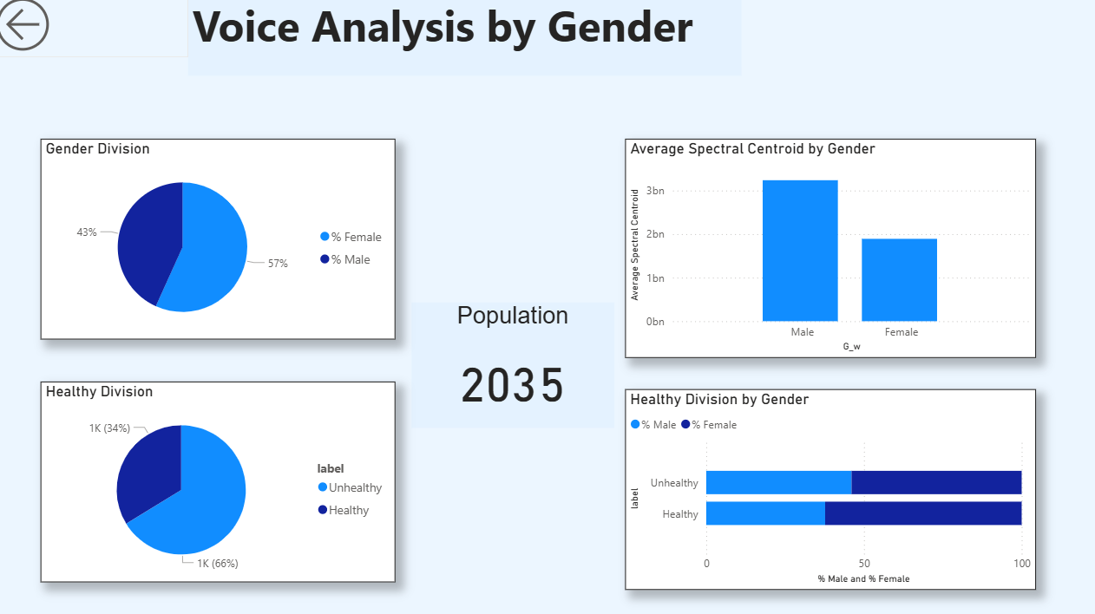

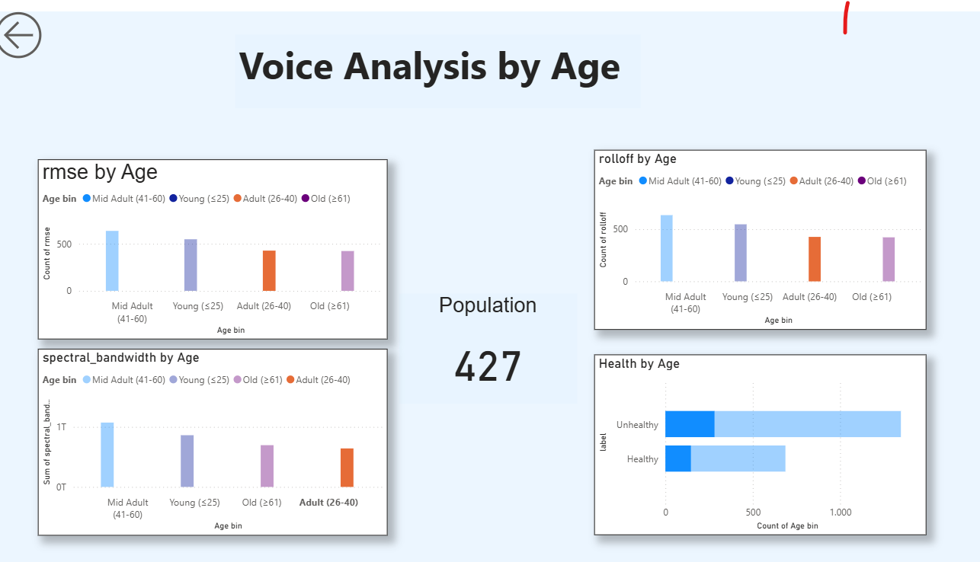

Screenshot Descriptions
- Screenshot 1: A pie chart displaying health status distribution by gender.
- Screenshot 2: A cluster chart displaying health status distribution by age.

Predictive Modeling Results

Models Overview
Two machine learning models were employed:
- Random Forest: An ensemble method leveraging multiple decision trees for robust classification.
- XGBoost: A gradient boosting algorithm known for its accuracy and efficiency in structured data tasks.

Training and Evaluation
The dataset was split into training (80%) and testing (20%) sets. Hyperparameter tuning was performed via grid search. Evaluation metrics included accuracy and F1 score.
- Random Forest achieved an accuracy of 85% and an F1 score of 0.83.
- XGBoost yielded slightly higher performance, with 87% accuracy and an F1 score of 0.85.

Summary and Conclusion
This project successfully demonstrated the feasibility of predicting health status from audio data using machine learning. The comprehensive workflow included detailed exploratory analysis, rigorous data cleaning, insightful Power BI visualizations, and robust predictive modeling. Key findings emphasized the relevance of vocal biomarkers and the effectiveness of Random Forest and XGBoost models. Future work may include expanding the dataset, incorporating deep learning approaches, and validating models in real-world clinical settings. Stakeholder engagement through interactive dashboards further enhanced the project's impact and accessibility.

